Cascaded Segmentation Detection Networks for Text Based Traffic Sign Detection
Abstract:
Since texts in traffic signs have precise and rich semantic information related to traffic condition, text-based traffic sign detection plays an important role in the autonomous driving and auxiliary driving of Intelligent Transportation System, just as traffic congestion detection, road detection, etc. The main difference between scene text detection and text-based traffic sign detection is that texts often fall on the traffic signs, so that the backgrounds of the texts in traffic sign are relatively clean. A new cascaded segmentation detection framework which is used to trained for text-based traffic sign detection. In this proposed system is to accurately detect the texts in traffic signs with high efficiency, fully avoiding the influence of background texts and symbol-based traffic signs. First traffic signs are segmented by using ROI (Region of Interest) to get the coarse area of traffic signs. Then the deep belief network is used in order to classify the text based traffic sign.
Existing System;
Text-based traffic sign detection is basically a special case of scene text detection. The main difference between scene text detection and text-based traffic sign detection is that texts often fall on the traffic signs, so that the backgrounds of the texts in traffic sign are relatively clean. A new cascaded segmentation detection framework which is used to trained for text-based traffic sign detection.
Proposed System;
In this proposed system is to accurately detect the texts in traffic signs with high efficiency, fully avoiding the influence of background texts and symbol-based traffic signs. First, traffic signs are segmented by using ROI (Region of Interest)) to get the coarse area of traffic signs. Then the deep belief network is used in order to classify the text based traffic sign.

Block Diagram:
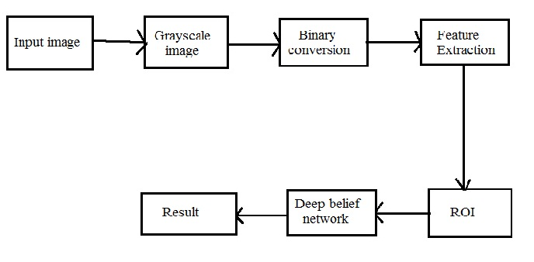
Module Description:
Module I: Preprocessing:
If the input images are color images means we are convert to gray scale from that color images. Then the binary conversion is used which 0 means black and 1 means white and the multimodal feature extraction is applied.
Module II: Segmentation:
Our goal is to accurately detect the texts in traffic signs with high efficiency, fully avoiding the influence of background texts and symbol-based traffic signs. So the ROI (Region of Interest) segmentation is used in order to segment the traffic sign.
Module III: Classify:
In this module the deep belief network is used in order to classify the text based traffic sign.
System Requirements:
SOFTWARE REQUIREMENTS:
- MATLAB R2013a
HARDWARE REQUIREMENTS:
- PC, Pentium 4 processor, 1 GB RAM, CPU 3.06 GHz

