Emerging From Water: Underwater Image Color Correction Based on Weakly Supervised Color Transfer

Alternate title
Underwater Image Analysis and Classification using Color Restoration with Neural Network Model

ABSTRACT:
Underwater images usually suffer from degeneration, such as low contrast, color casts, and noise, due to wavelength-dependent light absorption and scattering. The attenuated direct transmission leads the intensity from the scene to be weaker and introduces color casts, while the surrounding scattered light causes the appearance of the scene to be washed out. Serious degeneration makes it difficult to recover the appearance and color of underwater images. Water GAN (generative adversarial network) can remove color distortion by weakly supervised model. However, color is extremely important for underwater vision tasks and researches The proposed system we used to improve the visibility of underwater images, early researchers use the traditional techniques of image processing.

EXISTING SYSTEM:
Underwater images usually suffer from degeneration, such as low contrast, color casts, and noise, due to wavelength-dependent light absorption and scattering. The scattering and absorption attenuate the direct transmission and introduce surrounding scattered light. The attenuated direct transmission leads the intensity from the scene to be weaker and introduces color casts, while the surrounding scattered light causes the appearance of the scene to be washed out. Besides Water GAN(generative adversarial network) shows limitation when it is used to process the underwater images captured under unknown sites.

PROBLEM FINDING:
How to effectively approximate the real color of underwater images is major problem.

PROPOSED SYSTEM:
In the proposed system we used to improve the visibility of underwater images, early researchers use the traditional techniques of image processing. We proposed a dehazing algorithm based on the difference structure preservation prior, which can estimate the optimal transmission map and restore the actual scene.
BLOCK DIAGRAM:

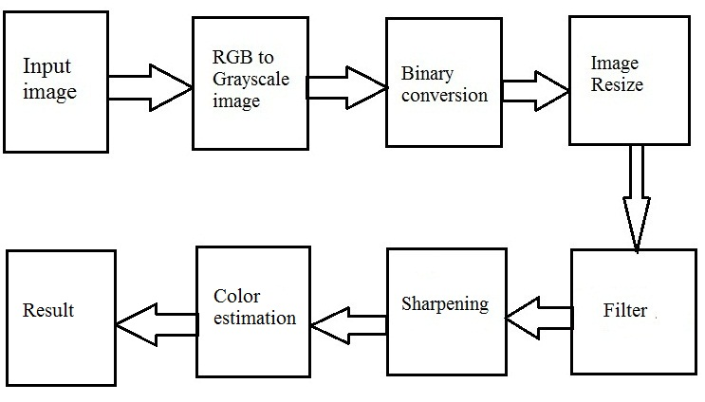

SYSTEM REQUIREMENTS:
- SOFTWARE REQUIREMENTS: MATLAB 7.6.0 (R2008a)
- HARDWARE REQUIREMENTS: PC, Pentium 4 processor, 1 GB RAM, CPU 3.06 GHz

