A Low-Power Sensitive Integrated Sensor System for Thermal Flow Monitoring
Proposed topic
FPGA based Low power highly sensitive Monitoring system for Incubators
Abstract
Recent developments of micro fabrication and nanofabrication technologies have led to various physical sensors and sensor electronics integrated on thin films. In the existing system, air flow sensor is used for analysis, air flow sensor can recognize short-term breathing patterns and the IC is reliable for long term operation. The current starved ring oscillator-based sensor read-out circuit architecture and sub threshold region operation make the design ideal for low-power applications. The test results show the power consumption of the prototype sensor read-out IC to be in the microwatt range. In the proposed system, an infant monitoring through incubator control is evaluated as an application in which the temperature sensor data, oxygen monitoring data, skin temperature data is being recorded and saved as dataset in the FPGA memory. Such data is given as input and preprocessed using wavelet filter and pattern is monitored and controlled by low power FPGA blocks. The sensitivity prediction is tuned to min of 0.01v. Modelsim software us used for Simulation and XILINX ISE used for implementation.
Existing System
In the existing system, air flow sensor is used for analysis, air flow sensor can recognize short-term breathing patterns and the IC is reliable for long term operation. The current starved ring oscillator-based sensor read-out circuit architecture and sub threshold region operation make the design ideal for low-power applications. The test results show the power consumption of the prototype sensor read-out IC to be in the microwatt range.
Problem Statement
- Only air flow sensor is analyzed
Proposed System
In the proposed system, an infant monitoring through incubator control is evaluated as an application in which the temperature sensor data, oxygen monitoring data, skin temperature data is being recorded and saved as dataset in the FPGA memory. Such data is given as input and preprocessed using wavelet filter and pattern is monitored and controlled by low power FPGA blocks. The sensitivity prediction is tuned to min of 0.01v. Modelsim software us used for Simulation and XILINX ISE used for implementation.
Solution statement
- Temperature sensor, Oxygen sensor data are analyzed
- Incubator application is extended
Block diagram
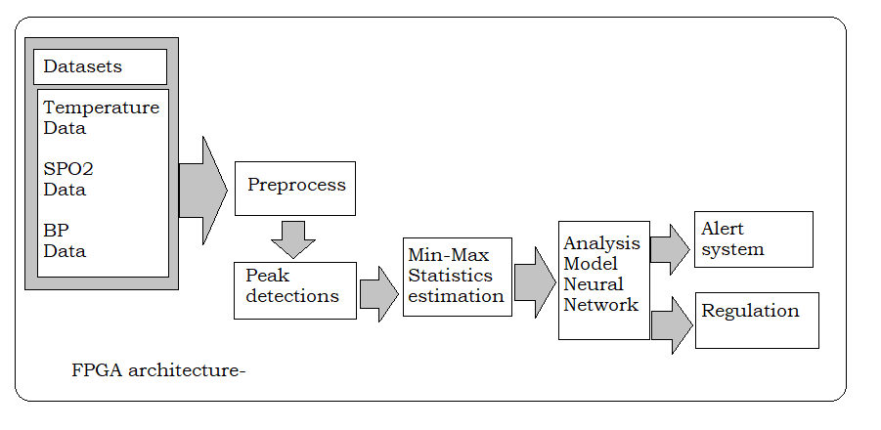

Software used
- MODELSIM / QUARTUS II
- XILINX ISE

