AF-DCGAN: Amplitude Feature Deep Convolutional GAN for Fingerprint Construction in Indoor Localization Systems
Proposed title
Smart indoor localization model through adaptive GAN for Secure infrastructure
Abstract
The demand for localization services increases, indoor localization technology based on fingerprint recognition has become the prevailing positioning technology due to its high precision and minimal hardware requirements. In addition to high accuracy, an indoor positioning system should have low complexity and require little processing time to accommodate mobile devices. Fingerprint-based indoor localization is an effective method that can satisfy these requirements; however, the received signal strength (RSS) or channel state information (CSI) from surrounding access points must be measured at each reference point to build a fingerprint database. In the existing system, keeping amplitude as a feature, deep convolutional GAN is developed in which the finger print construction through amplitude of the recorded signal is used for authentication. In the Proposed system, RSSI values are generated from Pseudo Signals generated for each devices, digitally modulated with the phase of the transmitting waves to generate communicating unique code. Further the system is provided with continuous protection through the generated Unique RSSI code. Further the system is tested using accuracy and sensitivity.
Existing system
The demand for localization services increases, indoor localization technology based on fingerprint recognition has become the prevailing positioning technology due to its high precision and minimal hardware requirements. In the existing system, keeping amplitude as a feature, deep convolutional GAN is developed in which the finger print construction through amplitude of the recorded signal is used for authentication.
Drawbacks
- Signal degradation can happen
- Signal interference due to RF amplitudes at high frequency
Proposed system
In the Proposed system, RSSI values are generated from Pseudo Signals generated for each devices, digitally modulated with the phase of the transmitting waves to generate communicating unique code. Further the system is provided with continuous protection through the generated Unique RSSI code. Further the system is tested using accuracy and sensitivity.
Advantages
- Adaptive GAN is used to validate
- Accuracy and sensitivity is improved
Proposed system
In the Proposed system, RSSI values are generated from Pseudo Signals generated for each devices, digitally modulated with the phase of the transmitting waves to generate communicating unique code. Further the system is provided with continuous protection through the generated Unique RSSI code. Further the system is tested using accuracy and sensitivity.
Future scope
- Secure indoor localization
- Smart Home systems and Smart infra-structure management

SYSTEM ARCHITECTURE

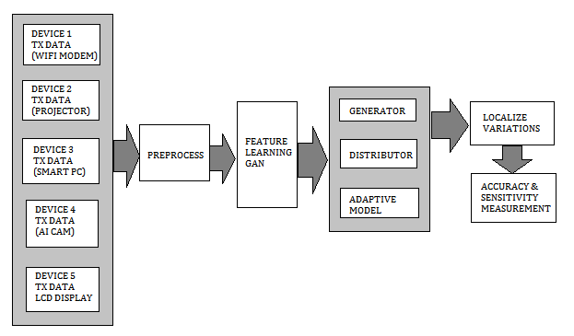

- Software Specs
- MATLAB 2020

